Name: ………………………………………. Class: ……………………………………..

Y9 RE KNOWLEDGE ORGANISER HOMEWORK SPRING

Unit 2: Issues of Equality

L1: Why is equality important?
L2: Religion and Equality
L3: Racism and Scripture
L4: The Fight for Racial Equality- Martin Luther King
L5: The Fight for Racial Equality- Malcolm X
L6: Gender Equality and Religion- Christianity
L7: Gender Equality and Religion- Islam
L8: LGBTQ+ Issues of Equality
L9: Issues of Disability Equality

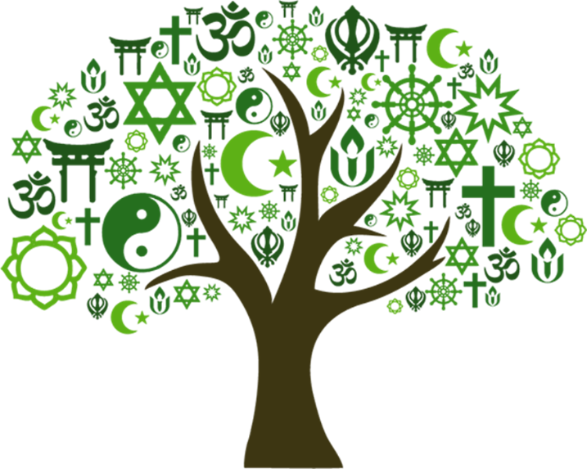

L1 Why is equality important?
- This is the definition for which word: Your social or professional standing. | Status
- This is the definition for which word: Your legal entitlement to particular things. | Rights
- This is the definition for which word: Your chances to do particular things. | Opportunities
- Fill in the gap: The opposite of equality is __________. | Inequality
- What word does each letter in the UNHRC stand for? | United Nations Human Rights Commission
L2 Religion and Equality
- Fill in the gap: People can have lots of different ___________ of religious texts. | Interpretations/  understandings
- “I say to you, a servant is not greater than his master.” Inequality OR equality? | Equality
- “I do not permit a woman to teach or to assume authority over a man.” Inequality OR equality? | Inequality
- “There is no superiority of a white person over a black person or of a black person over a white person.” Inequality OR equality? | Equality
- “Men are the caretakers of women.” Inequality OR equality? | Inequality
L3 Racism and Scripture
- Which religious text was originally used to justify the slave trade? | The Bible
- The word liberation means? | Freedom
- In a “slave Bible”, which part of the scripture was removed? | Exodus
- Why was the scripture removed? | As it might inspire rebellion
- People who supported slavery were known as abolitionists. True or False. | False
L4 The Fight for Racial Equality- Martin Luther King
- The Civil Rights Movement was a political movement and campaign from 1954 to 1968. True or False. | True.
- Which religion did Martin Luther King belong to? | Christianity
- Which nonviolent thinker inspired Martin Luther King? | Mohandas Gandhi
- King was also inspired by the teachings of…? | Jesus
- King campaigned against separating people based on race, known as? | Racial segregation
L5: The Fight for Racial Equality- Malcolm X
- Which religion was Malcolm X born into? | Christianity
- Which religion did Malcolm X then convert to? | Islam
- Martin Luther King and Malcolm X agreed on a philosophy of nonviolence. True or False. | False
- Both Martin Luther King Jr and Malcolm X were assassinated. What is an assassination? | A political murder
- What pilgrimage was life-changing for Malcolm X? | Hajj
L6: Gender equality and religion- Christianity
- Fill in the gaps: “I do not permit a woman to t____ or to assume a_______ over a man.” from the B____. | teach, authority, Bible
- In the early Christian church, Jesus’ disciples (followers) were all men. True or False. | True
- Which year was the Equality Act to prevent discrimination based on gender? | 2010
- Which body part of Adam’s does Genesis 2 state that Eve is made from? | Rib
- Some of Jesus’ closest followers were women. True or False. | True
L7: Gender equality and religion- Islam
- Fill in the gaps: Men are the c_______ of women, as men have been provisioned by A____.” From the Q_____. | Caretakers, Allah, Qur’an
- Fill in the gap: The Qur’an states that all humans are created from one s___ so we are all equal. | soul
- Gender does not matter whether a person can be a good Muslim. True or False. | True
- What were the names of Muhammad’s wives who led prayer? | Aisha and Umm Salamah
- Traditionally, men and women have both been imams. True or False. | False
L8: LGBTQ+ Issues of Equality
- Gay marriage became legal in England, Scotland and Wales in which year? | 2014
- Who is used against homosexuality because of their primary precept of reproduction? | Thomas Aquinas
- Choosing the parts that you like/do not like is known as…? | Cherry-picking
L9: Issues of Disability Equality
- How people treat people with disabilities is what kind of barrier? | Attitudinal
- Physical surroundings which impact the lives of people with disabilities is what kind of barrier? | Environmental
- Organisations who do not address issues of disability enough is what kind of barrier? | Institutional
- Fill in the gaps: One problem with Christianity was viewing disability as a p_______ for s___. | punishment, sin
- Fill in the gaps: Another problem with Christianity was viewing people with disabilities as c____ for c______. | cases, charity

